General Biology Year 11 2021

Unit 1 - Classification and cell processes

Task 1: Practical – Using a dichotomous key to identify organisms

(weighting 5%)

|  |  |  |  |
| --- | --- | --- | --- |
| **Name:** | **Teacher: Mr Groznica** | **Date:** | **Score:**  / |

The development and use of dichotomous keys make identification and communication easier and more accurate and also reflects evolutionary relationships. A dichotomy is the division of a group into smaller sub-groups. Each group contains members that share one characteristic. There are many characteristics that may be used but the most practical is anatomical structure.

Lake Richmond is a freshwater lake in Rockingham, Western Australia.

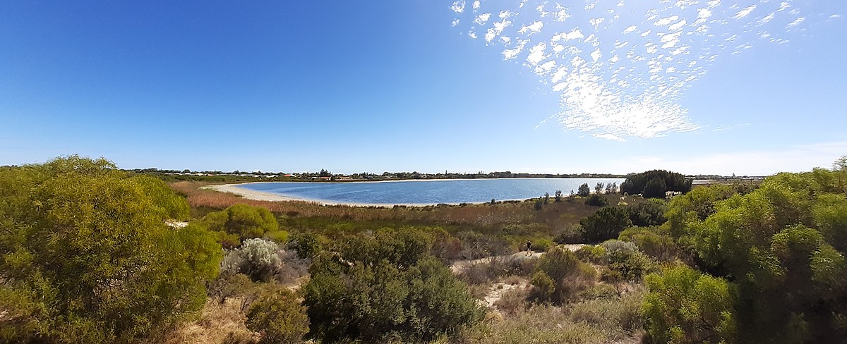

The Australian pelican, black swan, Australian shelduck, musk duck, white-faced heron and common greenshank are among the waterbirds that populate the 40-hectare, 15-metre-deep **Lake Richmond**.

The dome-shaped thrombolites of Lake Richmond are built by microorganisms that resemble the earliest life on Earth—a factor which has helped scientists unravel the secrets of how life began on the planet. Some 3,500 million to 650 million years ago, such organisms were the only known life forms on Earth and the thrombolites and stromatolites they constructed dominated the clear, shallow seas of this period, forming extensive reef tracts rivalling those of modern coral reefs. Today these once-dominant organisms are restricted to just a few places.

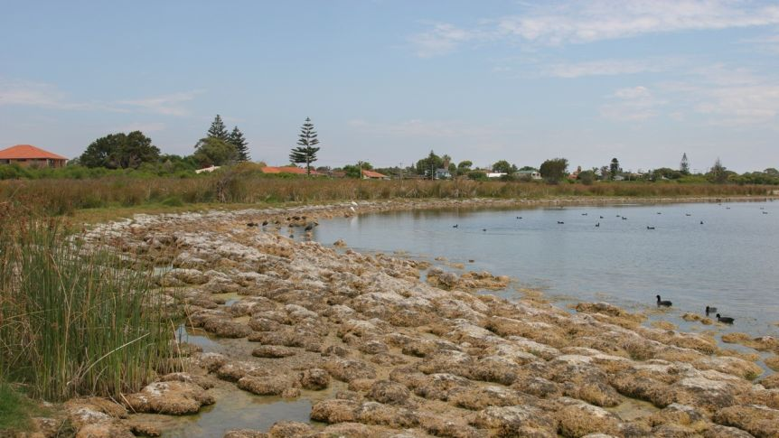

**TASK**

**Follow the information provided to answer the following problems.**

1. Look at the illustrations of aquatic organisms found in our local area.

**Group A Aquatic Organisms**

1. In the branching key below, separate the aquatic organisms into two groups. All the organisms in one group will share one characteristic while the organisms in the second group will not have that characteristic.

Organisms with tail filaments in one group, organisms without tail filaments in the second group.

All Organisms

No tail filaments

________________________________________________________

Tail filaments

____________________________________________________

1. Using the organism cards, complete the branching key by creating a dichotomous key. Fill out the empty part of the tree by writing in the text boxes, write in the characteristic that you would use at each dichotomy, then the list of organisms that belong in each box. You will need to resize the boxes, add additional boxes and arrows. (6 marks)
2. Look at aquatic organisms in **Group B** below.

**Group B Aquatic Organisms**

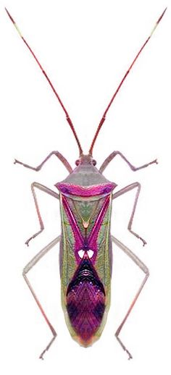

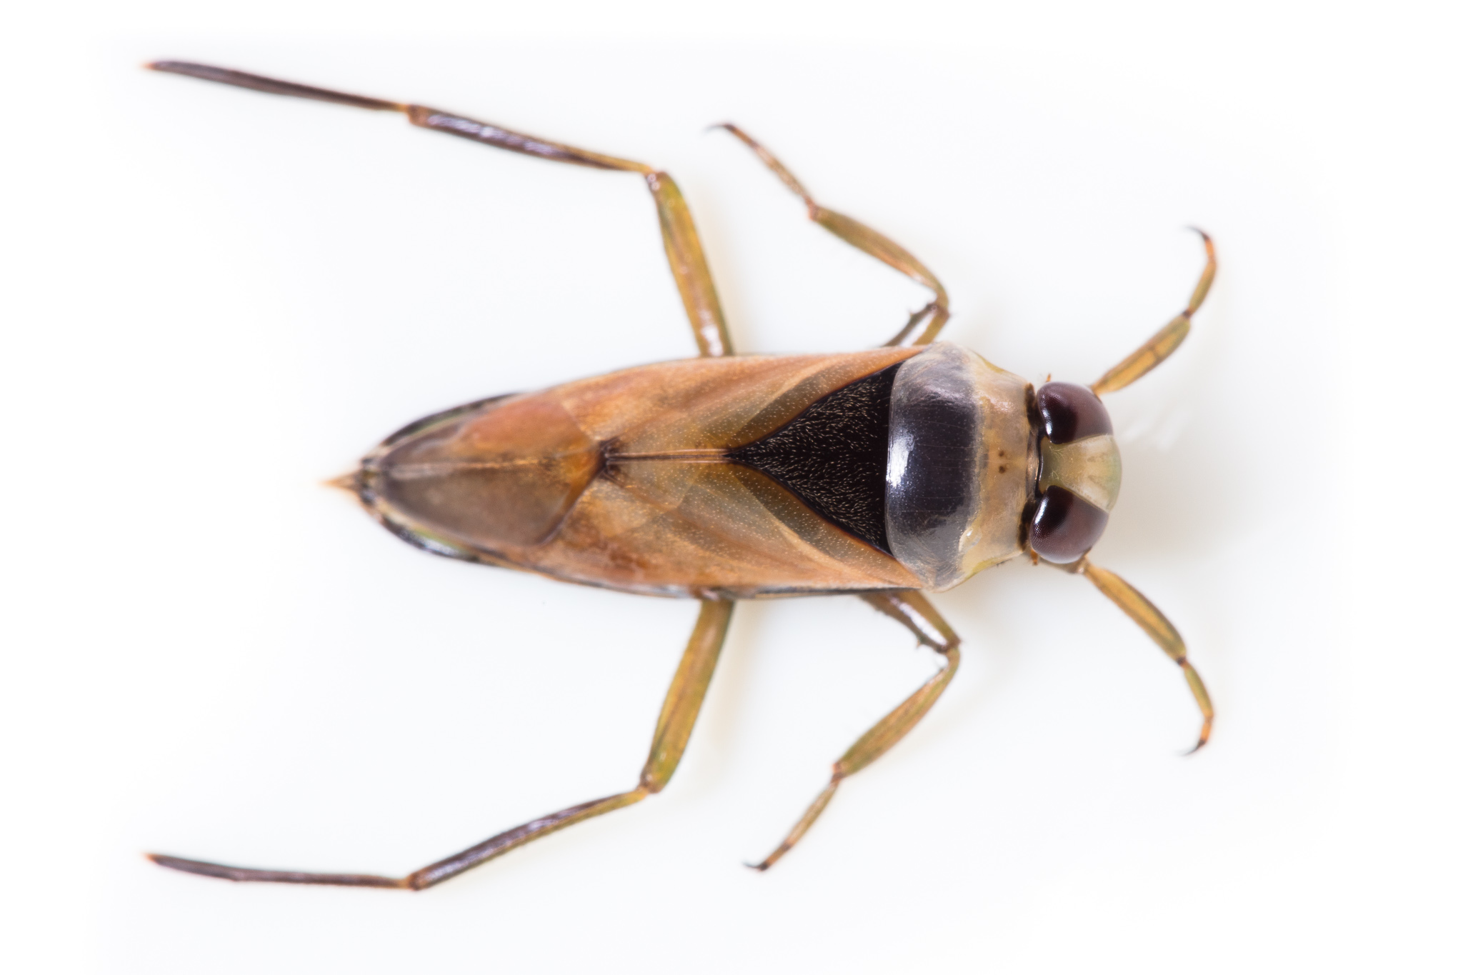

**A B**

1. Try to use your key to identify them. Using a different colour pen add Group B organisms to your key. (2 marks)

________________________________________________________________________________________________________________________________________________________________________________________________________________________________________________

1. How would you need to modify your key to include Organism A in the All Organisms group? (2 marks)

________________________________________________________________________________________________________________________________________________________________________________________________________________________________________________

1. Now complete the compact, numbered key below using the same organisms from **Group A**. You need to add extra numbers as you go: (5 marks)

1a Organisms with tail filaments Go to q2

1b Organisms without tail filaments Go to q

2a

2b

3a

3b

4a

4b

1. Which of the two keys (compact & numbered) do you find easier to use? Explain why. (2.5 marks)

________________________________________________________________________________________________________________________________________________________________________________________________________________________________________________

1. Use the simplified key below to identify each of the orders (by order or common name) of aquatic insects in **Group A Aquatic Organisms**. (4.5 marks)

1. Order of insect A ______________________________
2. Order of insect B ______________________________
3. Order of insect C ______________________________
4. Order of insect D ______________________________
5. Order of insect E ______________________________
6. Order of insect F ______________________________
7. Order of insect G ______________________________
8. Order of insect H ______________________________
9. Order of insect I ______________________________

**GROUP A**

**GROUP B**